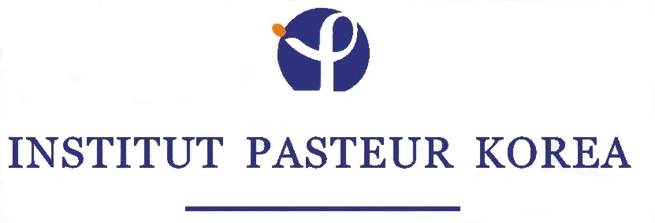

Institut Pasteur Korea (IP-Korea)

Call for Group Leader Positions at the Institut Pasteur Korea
(located on the campus of the Korea Institute of Science and Technology (KIST) in Seoul, Republic of Korea)

The newly established Institut Pasteur Korea is opening research positions for outstanding scientists to lead research groups in scientific areas related with the strategic interests of the “IP-Korea Genome to Drug Research Program”, which include:
- Plasmodium antigenic variation and motility
- Tuberculosis, with emphasis on the cell biology of Mycobacterium infection
- Stomach cancer/Helicobacter pylori, with emphasis on the early inflammatory response
- Physical and optical instrumentation in HTS and cellular imaging
- Computational imaging and vision
- Molecular beacons and quantum dots
- Chemical derivatization and surface chemistry
- Organometallic chemistry for molecular probes
- As well as other topics of interest to the program of IP-Korea

Group leaders will be appointed for an initial period of five years, extendable for additional 4 years. Each group (normally, of 5 to 6 people), will be allocated a technician position (for 5 years), a post-doctoral fellowship (for 5 years), and funding for two PhD students as well as research budget and equipment. The allocated research budget will be in accordance with the activity.

Candidates should have several years of post-doctoral experience and a strong track record in research. Salaries will be commensurate with experience and achievements.
Letters of intent (in English, 3 pages max.), a detailed Curriculum Vitae, a description of past activities as well as contact information of three references should be submitted electronically before May 30th, 2004 to: slee@pasteur.or.kr. Only a short list of candidates will be further contacted for interviews and to give a seminar in Seoul.
*Applicants to be considered for 5-year group leader positions are:
- Exceptional young researchers of any nationality
(2) Existing research group PIs in Korea (National Research Institutes, Universities and Industry) who have the possibility of being affiliated to the IP-Korea research program provided they will adapt their research program to the strategic objectives of IP-Korea.

